BizTalk DLAP Application Import Installation

Change History

|  |  |  |  |
| --- | --- | --- | --- |
| Version # | Date | Modified By | Description |
| 2.0.0.1 | 03/02/2018 | Ashok Pudota | Updated Deployment Version from 2.0.0.0 to 2.0.0.1  Updated Mapping for the Record Type Values.  Updated Oracle Application Request Schema and mapping for the Paper Application. |
| 2.0.0.2 | 03/09/2018 | Ashok Pudota | Updated Deployment Version from 2.0.0.1 to 2.0.0.2  Updated insurance and mortgage mapping for multiple  Update Asset Income Mapping for Gross and Other income nodes.  BRE Rules Version is 2.0.0.1 |
| 2.0.0.3 | 03/16/2018 | Ashok Pudota | Updated Deployment Version from 2.0.0.2 to 2.0.0.3  Updated Account, Contact and multiple Debts mapping.  Update Asset Income Mapping for Gross and Other income new SF nodes.  Updated Account, Contact, Income Assets, Debts Schemas with new SF elements.  BRE Rules Version is 2.0.0.1 |
| 2.0.0.4 | 03/19/2018 | Ashok Pudota | Updated Deployment Version from 2.0.0.3 to 2.0.0.4  Updated Mortgage Child Orchestration as Optional.  BRE Rules Version is 2.0.0.1 |
| 2.0.0.5 | 03/22/2018 | Ashok Pudota | Updated Deployment Version from 2.0.0.4 to 2.0.0.5.  Updated Applicant Consent mapping.  Updated Document Coordinator Orchestration for Application PDF and link only to Application.  Updated Document Coordinator Mapping for DLAPUser and Document Types.  BRE Rules Version is 2.0.0.1 |
| 2.0.0.6 | 03/22/2018 | Ashok Pudota | Updated Deployment Version from 2.0.0.5 to 2.0.0.6.  Updated mapping to Insurance information is within a Dmg_Properties.  Implemented Logic to Receive Multiple applications from Oracle.  Removed mapping for unwanted Assets, Income and Wages elements.  Updated Applicant External id and Event Request Mapping.  BRE Rules Version is 2.0.0.1 |
| 2.0.0.7 | 03/22/2018 | Ashok Pudota | Updated Deployment Version from 2.0.0.6 to 2.0.0.7.  Updated Event Request Mapping Logic.  BRE Rules Version is 2.0.0.1 |
| 2.0.0.8 | 04/02/2018 | Ashok Pudota | Updated Deployment Version from 2.0.0.7 to 2.0.0.8.  Updated Mapping for the following elements;   * + External_ID__c   + Borrower_Guarantor__c   + Tax_ID__c   + Contact-Phone   + Entity_Type__c   + Agree_to_Terms__c   + Record types, Applicant_Business_Owner has been renamed as Individual   BRE Rules Version is 2.0.0.2 |
| 2.0.0.9 | 04/16/2018 | Ashok Pudota | Updated Deployment Version from 2.0.0.8 to 2.0.0.9.  Updated Mapping for the following elements:  Mapping Family Size to applicant, not contact.  Mapping Family Size to application  Added Summary Decline to Auto Decline Reason.  Fixed Rep Fee mapping.  Fixed decline code mapping issue.  Updated shred event log code to version 2.0.0.0 to support Auto Decline Reason  BRE Rules Version is 2.0.0.2 |
| 2.0.0.10 | 04/18/2018 | Ashok Pudota | Updated Deployment Version from 2.0.0.9 to 2.0.0.10.  Updated Record Type ID mapping for Applicant and Application.  BRE Rules Version is 2.0.0.2 |
| 2.0.0.11 | 04/30/2018 | Ashok Pudota | Updated Deployment Version from 2.0.0.10 to 2.0.0.11.  Updated and Fixed Business Mapping  BRE Rules Version is 2.0.0.2 |
| 2.0.0.12 | 05/02/2018 | Ashok Pudota | Updated Deployment Version from 2.0.0.11 to 2.0.0.12.  Updated and Fixed Business Mapping  BRE Rules Version is 2.0.0.2 |
| 2.0.0.13 | 05/03/2018 | Ashok Pudota | Updated Deployment Version from 2.0.0.12 to 2.0.0.13.  Updated and Fixed Business Mapping  BRE Rules Version is 2.0.0.2 |
| 2.0.0.14 | 05/04/2018 | Ashok Pudota | Updated Deployment Version from 2.0.0.13 to 2.0.0.14.  Updated and Fixed Business Mapping  BRE Rules Version is 2.0.0.2 |
| 2.0.0.15 | 05/07/2018 | Ashok Pudota | Updated Deployment Version from 2.0.0.14 to 2.0.0.15.  Updated and Fixed Business Mapping  BRE Rules Version is 2.0.0.2 |
| 2.0.0.16 | 05/08/2018 | Ashok Pudota | Updated Deployment Version from 2.0.0.15 to 2.0.0.16.  Updated and Fixed Business Mapping  BRE Rules Version is 2.0.0.2 |
| 2.0.0.17 | 05/09/2018 | Ashok Pudota | Updated Deployment Version from 2.0.0.16 to 2.0.0.17.  Fixed ELA Application mapping issue and Updated Mapping for Business.  BRE Rules Version is 2.0.0.2 |
| 2.0.0.18 | 05/22/2018 | Ashok Pudota | Updated Deployment Version from 2.0.0.17 to 2.0.0.18.  Fixed Following issues:   1. DCMM-3730 2. DCMM-3505 3. DCMM-3655 4. DCMM-3656 5. DCMM-3657 6. DCMM-3717   BRE Rules Version is 2.0.0.2 |
| 2.0.0.19 | 05/22/2018 | Ashok Pudota | Updated Deployment Version from 2.0.0.18 to 2.0.0.19.  Updated Other Assistance Processing Logic as Optional.  BRE Rules Version is 2.0.0.2 |
| 2.0.1.0 | 05/30/2018 | Ashok Pudota | Updated Deployment Version from 2.0.0.19 to 2.0.1.0.  Fixed Following issues:  DCMM-2928  DCMM–3155  DCMM-3905  BRE Rules Version is 2.0.0.2 |
| 2.0.2.0 | 05/31/2018 | Ashok Pudota | Updated Deployment Version from 2.0.1.0 to 2.0.2.0.  Fixed Following issues:  DCMM-3940  BRE Rules Version is 2.0.0.2 |
| 2.0.2.1 | 06/05/2018 | Ashok Pudota | Updated Deployment Version from 2.0.2.0 to 2.0.2.1.  Fixed Following issues:  DCMM- 3874  Fixed Document type mapping.  BRE Rules Version is 2.0.0.2 |
| 2.0.2.2 | 06/07/2018 | Ashok Pudota | Updated Deployment Version from 2.0.2.1 to 2.0.2.2.  Fixed Following issues:  DCMM-4069  BRE Rules Version is 2.0.0.2 |
| 2.0.2.3 | 06/07/2018 | Ashok Pudota | Updated Deployment Version from 2.0.2.2 to 2.0.2.3.  Fixed Following issues:  DCMM- 3910  BRE Rules Version is 2.0.0.2 |
| 2.0.4.1 | 06/20/2018 | Ashok Pudota | Updated Deployment Version from 2.0.2.3 to 2.0.4.1.  Fixed Following issues:  DCMM- 4193( Other debts mapping fixed)  BRE Rules Version is 2.0.0.2 |
| 2.0.4.2 | 06/22/2018 | Ashok Pudota | Updated Deployment Version from 2.0.2.3 to 2.0.4.1.  Fixed Following issues:  DCMM-4244(Updated Rental Property Debts Mapping)  BRE Rules Version is 2.0.0.2 |
| 2.0.4.4 | 06/29/2018 | Ashok Pudota | Updated Deployment Version from 2.0.4.2 to 2.0.4.4.  Fixed Following issues:  DCMM-2815(Implemented Intermediate DLAP Status Change Logic)  BRE Rules Version is 2.0.0.2 |
| 2.0.5.0 | 07/10/2018 | Ashok Pudota | Updated Deployment Version from 2.0.4.4 to 2.0.5.0.  Fixed Following issues:  DCMM-3784  DCMM-4339  DCMM-4287  BRE Rules Version is 2.0.0.2 |
| 2.0.5.5 | 07/19/2018 | Ashok Pudota | Updated Deployment Version from 2.0.4.4 to 2.0.5.0.  Fixed Following issues:  DCMM-4347  BRE Rules Version is 2.0.0.2 |
| 2.0.7.2 | 08/01/2018 | Ashok Pudota | Updated Deployment Version from 2.0.5.5 to 2.0.7.2.  Fixed Following issues:  DCMM-4802  BRE Rules Version is 2.0.0.2 |
| 2.0.7.8 | 08/21/2018 | Ashok Pudota | Updated Deployment Version from 2.0.7.2 to 2.0.7.8.  Fixed Following issues:  DCMM-5082  BRE Rules Version is 2.0.0.2 |
| 2.0.8.3 | 09/05/2018 | Ashok Pudota | Updated Deployment Version from 2.0.7.8 to 2.0.8.3  Fixed Following issues:  DCMM-4884  BRE Rules Version is 2.0.0.2 |
| 2.0.9.5 | 10/10/2018 | Ashok Pudota | Updated Deployment Version from 2.0.8.3 to 2.0.9.5  Fixed Following issues:  DCMM-5548  BRE Rules Version is 2.0.0.2 |
| 2.0.9.10 | 11/02/2018 | Ashok Pudota | Updated Deployment Version from 2.0.9.5 to 2.0.9.10  Fixed Following issues:  DCMM-5345  DCMM-5642  DCMM-3953  BRE Rules Version is 2.0.0.2 |
| 2.0.11.0 | 01/18/2018 |  | Updated Deployment Version from 2.0.9.10 to 2.0.11.0  Fixed Following issues:  DCMM-5637  DCMM-6232  BRE Rules Version is 2.0.0.2 |

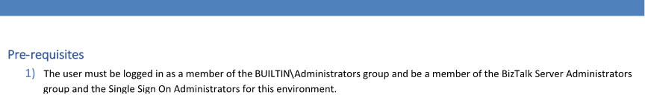

# Uninstallation:

1. Locate, Stop and unenlist all DLAP Application Import Ports and Orchestrations
   1. Orchestrations: Search for Application_Import_Logic and Document_Upload_Logic
   2. Send Ports: Search for DLAP Application Import
   3. Receive Locations: Search for DLAP Application Import
2. Delete the DLAP Application Import Assemblies 2.0.9.10 from the Resource Group

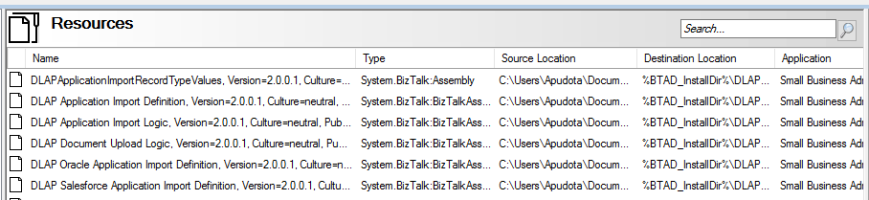

# Special Note:(Update Record Type Values Rules on Each Environment)

1. **DEVINT: RecordType Values**

|  |  |  |  |
| --- | --- | --- | --- |
| **SobjectType** | **SFRecordTypeName** | **BRE Element Names** | **Id** |
| Application__c | Business_Loan_Application | Business_Loan_Application | 012r000000056gYAAQ |
| Application__c | EIDL_Application | EIDL_Application | 012r000000056gZAAQ |
| Application__c | New_Read_Only | New_Read_Only_Application | 012r00000005SNLAA2 |
| Application__c | Home_Loan_Application | Home_Loan_Application | 012r000000056gaAAA |
| Applicant__c | Default | Default_Applicant | 012r00000005SNJAA2 |
| Applicant__c | New_Read_Only | New_Read_Only_Applicant | 012r00000005SNKAA2 |
| Applicant__c | Affiliate | Applicant_Affiliate | 012r00000005lGHAAY |
| Applicant__c | Business_Entity | Applicant_Business_Entity | 012r00000005lGIAAY |
| Applicant__c | Business_Owner | Individual | 012r00000005lGJAAY |

# DEVINT2: RecordType Values

|  |  |  |  |
| --- | --- | --- | --- |
| **SobjectType** | **SFRecordTypeName** | **BRE Element Names** | **Id** |
| Application__c | Business_Loan_Application | Business_Loan_Application | [012350000000Om6AAE](https://na01.safelinks.protection.outlook.com/?url=https%3A%2F%2Fworkbench.developerforce.com%2Fretrieve.php%3Fid%3D012350000000Om6AAE&data=02%7C01%7CSteven.Henn%40sba.gov%7Cf7b3812116344113e23908d58dab6f75%7C3c89fd8a7f684667aa1541ebf2208961%7C1%7C0%7C636570689822286094&sdata=rjVuREA92IWVx%2FMbfOUSqTgtqoAGcP45EUuGoV%2FIs1Y%3D&reserved=0) |
| Application__c | EIDL_Application | EIDL_Application | [012350000000Om7AAE](https://na01.safelinks.protection.outlook.com/?url=https%3A%2F%2Fworkbench.developerforce.com%2Fretrieve.php%3Fid%3D012350000000Om7AAE&data=02%7C01%7CSteven.Henn%40sba.gov%7Cf7b3812116344113e23908d58dab6f75%7C3c89fd8a7f684667aa1541ebf2208961%7C1%7C0%7C636570689822286094&sdata=A7fEwDukgPKxGnM0Z4gp%2Fmz8KEuhEcUje%2BCpv3GXYUI%3D&reserved=0) |
| Application__c | New_Read_Only | New_Read_Only_Application | [012350000000Om9AAE](https://na01.safelinks.protection.outlook.com/?url=https%3A%2F%2Fworkbench.developerforce.com%2Fretrieve.php%3Fid%3D012350000000Om9AAE&data=02%7C01%7CSteven.Henn%40sba.gov%7Cf7b3812116344113e23908d58dab6f75%7C3c89fd8a7f684667aa1541ebf2208961%7C1%7C0%7C636570689822286094&sdata=AtOEysfQtFRxpy7zYJDfc9hpxe1A4sPrP2w%2FyaDUZYM%3D&reserved=0) |
| Application__c | Home_Loan_Application | Home_Loan_Application | [012350000000Om8AAE](https://na01.safelinks.protection.outlook.com/?url=https%3A%2F%2Fworkbench.developerforce.com%2Fretrieve.php%3Fid%3D012350000000Om8AAE&data=02%7C01%7CSteven.Henn%40sba.gov%7Cf7b3812116344113e23908d58dab6f75%7C3c89fd8a7f684667aa1541ebf2208961%7C1%7C0%7C636570689822286094&sdata=O%2Bt6n8uWNjHlFjPFs17ida21%2Bbax42dV7yr3t6bX69k%3D&reserved=0) |
| Applicant__c | Default | Default_Applicant | [012350000000Om2AAE](https://na01.safelinks.protection.outlook.com/?url=https%3A%2F%2Fworkbench.developerforce.com%2Fretrieve.php%3Fid%3D012350000000Om2AAE&data=02%7C01%7CSteven.Henn%40sba.gov%7Cf7b3812116344113e23908d58dab6f75%7C3c89fd8a7f684667aa1541ebf2208961%7C1%7C0%7C636570689822286094&sdata=rY5DlhNxnIG%2BSWB7z4zGQOnnHqdmmqAWvCuQxZDXgns%3D&reserved=0) |
| Applicant__c | New_Read_Only | New_Read_Only_Applicant | [012350000000Om3AAE](https://na01.safelinks.protection.outlook.com/?url=https%3A%2F%2Fworkbench.developerforce.com%2Fretrieve.php%3Fid%3D012350000000Om3AAE&data=02%7C01%7CSteven.Henn%40sba.gov%7Cf7b3812116344113e23908d58dab6f75%7C3c89fd8a7f684667aa1541ebf2208961%7C1%7C0%7C636570689822286094&sdata=MEnKWEBf7IRzVEP6NQKSUII%2FhHdEqol%2FdWe%2B%2BhC%2FUqk%3D&reserved=0) |
| Applicant__c | Affiliate | Applicant_Affiliate | [012350000000OlzAAE](https://na01.safelinks.protection.outlook.com/?url=https%3A%2F%2Fworkbench.developerforce.com%2Fretrieve.php%3Fid%3D012350000000OlzAAE&data=02%7C01%7CSteven.Henn%40sba.gov%7Cf7b3812116344113e23908d58dab6f75%7C3c89fd8a7f684667aa1541ebf2208961%7C1%7C0%7C636570689822286094&sdata=s7PilETt%2BnbLayJ8dvL3ULTQku79OcpAsKt3ufMUBwA%3D&reserved=0) |
| Applicant__c | Business_Entity | Applicant_Business_Entity | [012350000000Om0AAE](https://na01.safelinks.protection.outlook.com/?url=https%3A%2F%2Fworkbench.developerforce.com%2Fretrieve.php%3Fid%3D012350000000Om0AAE&data=02%7C01%7CSteven.Henn%40sba.gov%7Cf7b3812116344113e23908d58dab6f75%7C3c89fd8a7f684667aa1541ebf2208961%7C1%7C0%7C636570689822286094&sdata=Z5RJbaH%2B092fG9GPJtmCcFHZCP2VW6Iq9v%2BIVNAyz0M%3D&reserved=0) |
| Applicant__c | Business_Owner | Individual | [012350000000Om1AAE](https://na01.safelinks.protection.outlook.com/?url=https%3A%2F%2Fworkbench.developerforce.com%2Fretrieve.php%3Fid%3D012350000000Om1AAE&data=02%7C01%7CSteven.Henn%40sba.gov%7Cf7b3812116344113e23908d58dab6f75%7C3c89fd8a7f684667aa1541ebf2208961%7C1%7C0%7C636570689822286094&sdata=WCn16mV6mgs0y74yD1TdB7H8KqTK94wfnhGZyDCfn9s%3D&reserved=0) |

# QA: RecordType Values

|  |  |  |  |
| --- | --- | --- | --- |
| **SobjectType** | **DeveloperName** | **Record Type ID** |  |
| Application__c | Business_Loan_Application | 012r00000001AvOAAU |  |
| Application__c | EIDL_Application | 012r00000001AvPAAU |  |
| Application__c | Home_Loan_Application | 012r00000001AvQAAU |  |
| Application__c | New_Read_Only | 012r00000005SNkAAM |  |
| Applicant__c | Default | 012r00000005SNiAAM |  |
| Applicant__c | New_Read_Only | 012r00000005SNjAAM |  |
| Applicant__c | Affiliate | 012r00000005mL3AAI |  |
| Applicant__c | Business_Entity | 012r00000005mL4AAI |  |
| Applicant__c | Business_Owner | 012r00000005mL5AAI |  |

1. Open “**DLAP Application Import BRE Rules 2.0.0.1.xml**” file and update record type values for every environment as shown in below figure.

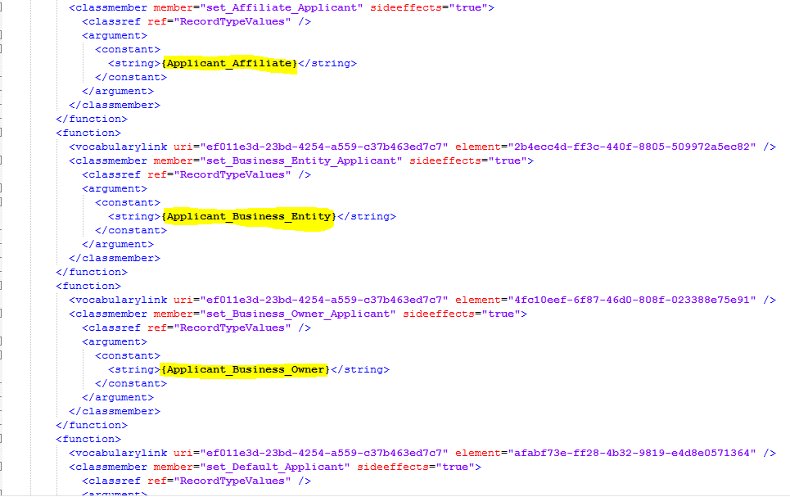

1. Deploy the Rules using BRE Deployment Wizard.

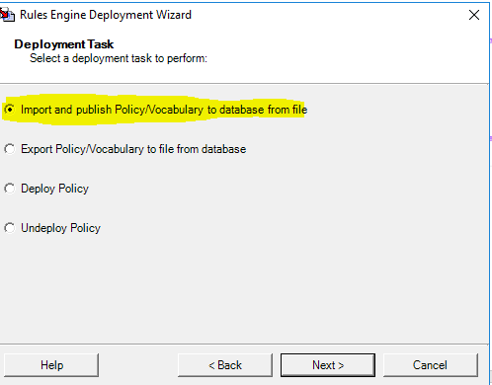

# Installation:

1. Locate the version 2.0.0.1 of the DLAP Application Import MSI and binding files in GIT Hub
   1. These are in the DLAP Application Import Branch of the on-premise repository **Git Hub DLAP-Application-Import**
   2. In the subfolder named **Deployment**
   3. Download the files into your environment
2. Open the DLAP Application Import Binding file with a text editor such as Notepad.
3. For each value below, search and replace the variable with the appropriate value for the environment.

|  |  |
| --- | --- |
| Value to search for | New Value sample |
| **{SFADDRESS}** | **https://*sba-oda--targetenv.cs32.my.salesforce.com*/services/Soap/c/40.0** |
| **{SFPASSWORD}** | ***biztalk-passsword*** |
| **{SFUSERNAME}** | ***biztalk-account@sba.gov.account*** |
| **{SFAPIKEY}** | ***biztalk-token*** |

|  |  |
| --- | --- |
| Value to search for | New Value sample – ORACLE IS USERNAMES ARE CASE SENSITIVE! |
| **{ORACLEUSERNAME}** | ***OracleUsername*** |
| **{ORACLEPASSWORD}** | ***oraclepwd*** |
| **{ORACLEADDRESS}** | ***ela_tnsname*.sba.gov** |
| LAST_UPDATED_BY = 'vmetst-oda-bz02' | **LAST_UPDATED_BY = *'the actual computer name'*** |

1. Save the updated file with the new values
2. Using the BizTalk Server Admin Console to complete the following steps
   1. Import the DLAP Application Import 2.0.0.1.MSI
   2. Import the updated DLAP Application Import 2.0.0.1.xml bindings
   3. Added the Polices 2.1 to the Application.
3. At the end of the import process, when asked, install the DLAP Application Import Application on the server.
   1. go to the Oracle receive location ("DLAP Application Import From Oracle") and change the "post poll" statement to reflect the correct machine
   2. Start the Send Ports, Orchestrations and enable the receive Ports for the Small Business Administration Application for DLAP Application Import.
   3. Restart the rules engine update service.